SIGN LANGUAGE RECOGNITION USING MACHINE LEARNING

Internship Project Report

Intern Details
Intern Name: Kaniyamuthu B
Intern ID: [Enter Your Intern ID]
Internship Domain: Artificial Intelligence
Project Title: Sign Language Recognition Using Machine Learning
Duration: [Enter Number of Weeks]

1. Abstract
Sign language is an important communication method used by hearing-impaired and speech-impaired individuals. This project aims to develop a Sign Language Recognition system using Machine Learning. The system recognizes hand gestures and converts them into understandable text labels. The project demonstrates how Artificial Intelligence and Computer Vision can be used to improve communication accessibility.

2. Introduction
Communication is essential in everyday life. People with hearing or speech disabilities often rely on sign language to communicate. However, not everyone understands sign language. This project focuses on recognizing hand gestures and translating them into readable outputs using machine learning techniques.
The system captures hand gesture data, processes it, and predicts the corresponding sign.

3. Objectives
The main objectives of this project are:
- To recognize sign language gestures using machine learning.
- To improve communication accessibility.
- To understand image-based machine learning applications.
- To demonstrate the use of Artificial Intelligence in Computer Vision.
- To classify hand gestures accurately.

4. Tools and Technologies Used
- Python
- Google Colab
- Pandas
- NumPy
- Scikit-Learn
- OpenCV
- Machine Learning Algorithms

5. Methodology

Step 1: Data Collection
A dataset containing sign language gesture samples was collected.

Step 2: Data Preprocessing
The gesture images were processed and converted into numerical values suitable for machine learning.

Step 3: Feature Extraction
Important features from gesture images were extracted to improve recognition accuracy.

Step 4: Model Training
The machine learning model was trained using labeled sign language data.

Step 5: Prediction
The trained model predicted the corresponding sign based on the input gesture.

6. Implementation
The implementation process included:
- Importing required libraries.
- Loading the sign language dataset.
- Preprocessing the gesture data.
- Training the machine learning model.
- Testing the model.
- Displaying prediction results.

8. Screenshots
Dataset Creation Output:
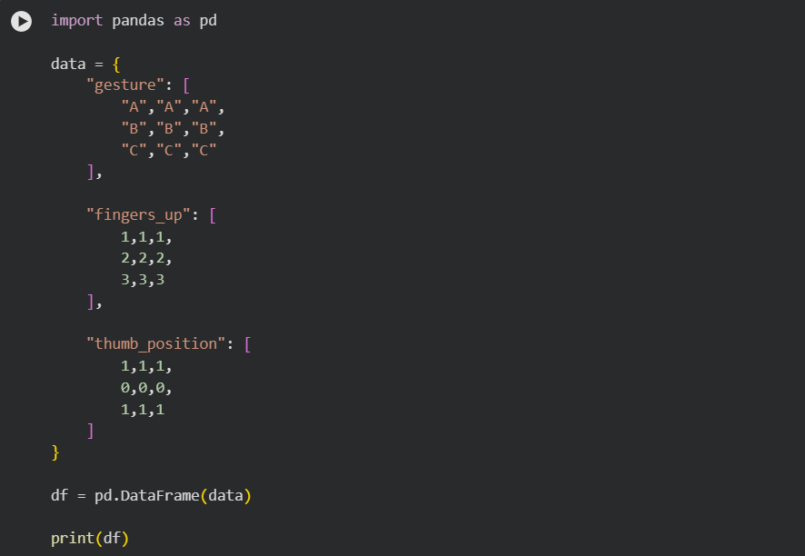
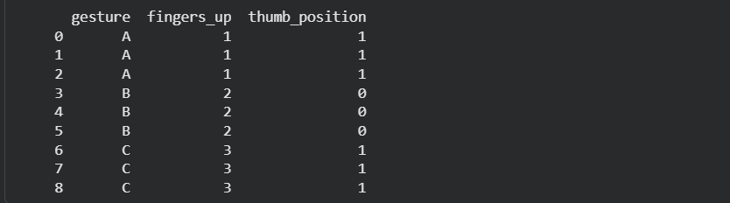
Model Trained Successfully Output:
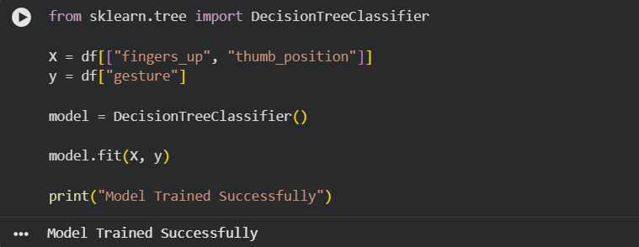
Prediction Result for Sign A:
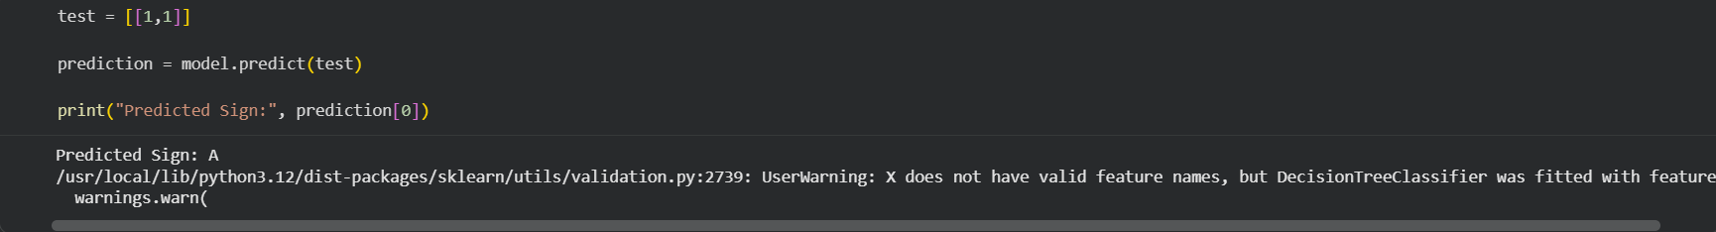
Prediction Result for Sign B:
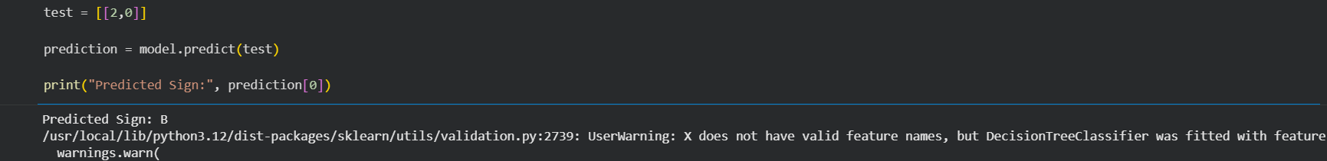
Prediction Result for Sign C:
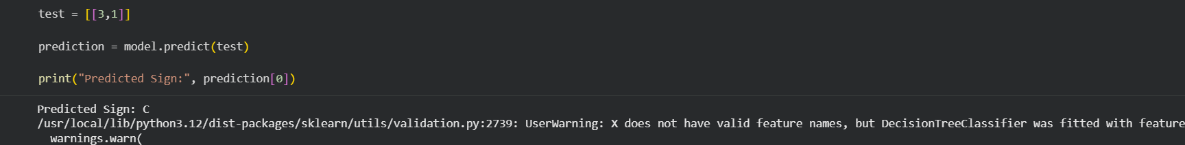

Project Completed Successfully Output:

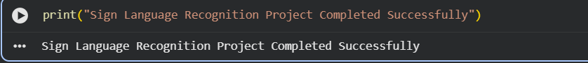

11. Future Enhancements
- Real-time webcam-based recognition.
- Support for complete sign language sentences.
- Mobile application development.
- Deep learning-based gesture recognition.
- Multi-language support.

12. Conclusion
The Sign Language Recognition project successfully demonstrates the use of Artificial Intelligence and Machine Learning in gesture recognition. The system can identify hand signs and convert them into meaningful outputs. This project highlights the potential of AI in creating inclusive technologies that support people with communication disabilities.

References
- Python Documentation
- OpenCV Documentation
- Scikit-Learn Documentation
- Google Colab Documentation
- Machine Learning and Computer Vision Resources

